**Award Tables**

# Geoff Anderson G3NPA and Aki Yoshida JA1NLX

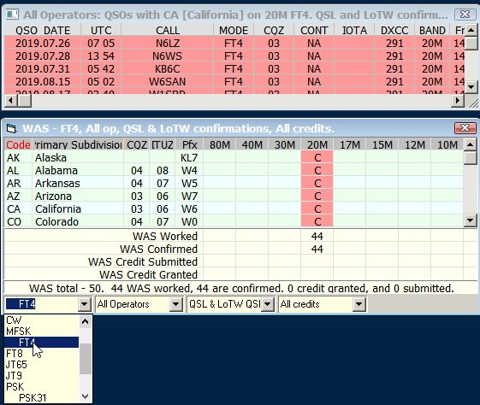

AT_3AB

**Award Table for IOTA**

Standard IOTA (All HF Bands) award counts QSOs only on HF Bands. If you want to see VHF/UHF award then check “VHF/UHF”.

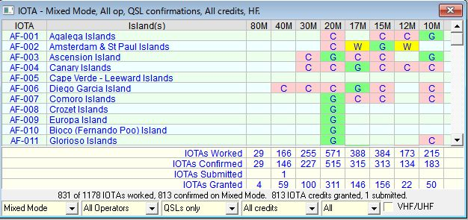

AT_3A

QSL type can be selected in QSL type dropdown list.



AT_3A1

Credit type can be selected in credit dropdown list.

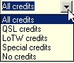

AT_3A2

A left-click on any of the “W”, “C”, "S" or "G" flags will bring up a further window showing the details of those contacted for the selected square. Example:

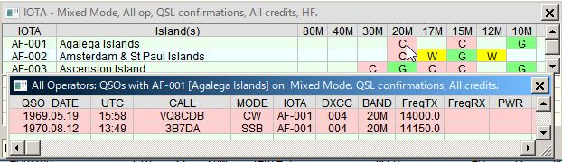

AT_3B